CANDIDATE INSTRUCTIONS

This process is designed to recognise your existing OHSCER or TLI/CPC training, and allow you to gain the equivalent RII certificate. It also allows for the granting of TLI/CPC certificates if you hold the equivalent OHSCER license.

Step 1: Locate all copies of existing Statements of Attainment for the High Risk Work Licenses that you have completed. Most likely, these will be OHSCER certificates.

Step 2: You will be able to transfer all of your OHSCER licenses to TLI or CPC equivalents, and many to RII. Check the listing below, and determine which TLI/CPC and RII units you wish to have recognized. Then complete Section A: Unit. If you are applying for multiple certificates, complete Attachment 1: Additional RII Units Requested on the Same Application for all the units you wish to apply for.

Step 3: Attach certified copies of your certificates to this application form, and forward for processing. There is a $80 processing fee per certificate for all certificates granted under a single application.

 | OHSCER Code | RII Unit Code | RII Unit Title | TLI/CPC  Course Code | TLI/LIC Unit Title
DG | OHSCER218A | RIIHAN208D | Perform Dogging | CPCCLDG3001A | Licence to perform dogging
HP | OHSCER238A | RIIHAN207D | Operate Personnel and Materials Hoist | CPCCLHS3001A | Licence to operate a personnel and materials hoist
HM | OHSCER237A |  |  | CPCCLHS3002A | Licence to operate a materials hoist
RB | OHSCER222A | RIIHAN209D | Perform Basic Rigging | CPCCLRG3001A | Licence to perform rigging basic level
RI | OHSCER223A | RIIHAN210D | Perform Intermediate Rigging operations | CPCCLRG3002A | Licence to perform rigging intermediate level
RA | OHSCER224A | N/A |  | CPCCLRG4001A | Licence to operate rigging advanced level
SB | OHSCER219A | RIIHAN211D | Conduct Basic Scaffolding Operations | CPCCLSF2001A | Licence to erect, alter and dismantle scaffolding basic level
SI | OHSCER220A | RIIHAN302D | Conduct Intermediate Scaffolding Operations | CPCCLSF3001A | Licence to erect, alter and dismantle scaffolding intermediate level
SA | OHSCER221A | N/A |  | CPCCLSF4001A | Licence to erect, alter and dismantle scaffolding advanced level
CV | OHSCER228A | RIIHAN307D | Operate a Vehicle Loading Crane | TLILIC0012A | Operate a Vehicle Loading Crane (capacity 10meter tonnes and above)
LF | OHSCER207A | RIIHAN201D | Operate a Forklift | TLILIC2001A | Licene to operate a forklift truck
LO | OHSCER208A |  |  | TLILIC2002A | Licence to operate an order picking forklift truck
WP | OHSCER235A | RIIHAN301D | Operate Elevating Work Platform | TLILIC2005A | Licence to operate a Boom Type Elevating Work Platform (EWP) – (boom 11m or more)
CD | OHSCER226A |  |  | TLILIC3004A | Licence to operate a derrick crane
CP | OHSCER227A |  |  | TLILIC3007A | Licence to operate a portal boom crane
CN | OHSCER230A | RIIHAN212D | Conduct Non-slewing Crane Operations | TLILIC3006A | Licence to Operate a Non-slewing Mobile Crane (greater than 3 tonnes capacity)
C2 | OHSCER231A | RIIHAN304D | Conduct Slewing Crane Operations | TLILIC3008A | Licence to Operate a Slewing Mobile Crane (up to 20 tonne)
C6 | OHSCER232A | RIIHAN304D | Conduct Slewing Crane Operations | TLILIC4009A | Licence to Operate a Slewing Mobile Crane (up to 60 tonne)
C1 | OHSCER233A | RIIHAN304D | Conduct Slewing Crane Operations | TLILIC4010A | Licence to Operate a Slewing Mobile Crane (up to 100 tonne)
CO | OHSCER234A | RIIHAN304D | Conduct Slewing Crane Operations | TLILIC4011A | Licence to Operate a Slewing Mobile Crane (OPEN)
LBG | OHSCER210A | RIIHAN305D | Operate Gantry or Overhead Crane | TLILIC3003A | Licence to operate a bridge and gantry crane

NOTES:

- Not all OHSCER or TLI/CPC units are offered in RII.
- All OHSCER units have an equivalent TLI/CPC unit available.
- There are a number of RII units that are not covered by this RPL process, but are on our scope and are available for training or a more detailed RPL process.
- All Slewing Mobile Cranes are covered under one RII certificate only – Conduct Slewing Crane Operations – so you will only need to apply for the one certificate regardless of which OHSCER crane license you hold. Evidence of your crane capacity skill set may still be required by your employer.
- Rigging Advanced and Scaffolding Advanced are not available under RII.

SECTION A – UNIT
RII Unit Code:
RII Unit Title:

SECTION B – CANDIDATE DETAILS
Personal Details
Salutation: |  | Mr Mrs Miss Ms  Other: _______________
First Name:
Last Name:
Other Names:
Date of Birth:
Gender: |  | Male Female
Home Address:
Postal Address:
Contact Mobile:
Other Phone:
Email Address:
Emergency Contact Details
Name:
Phone:
Evidence of Person (Photo ID – must be sighted)
Type: | D/L Passport 18+ ____________
Number: |  |  | Exp Date:

SECTION C – PAYMENT DETAILS (If not finalised)
Type | Visa Mastercard Cash  Invoice Corporate
Name on Card:
Card Number:
Exp Date:
Payment Amnt:
Cardholder Signature:

SECTION D – GOVERNMENT SURVEY
Is this training provided by your employer?
N Y Name: _______________________________
What is your current employment status: (Pls check one)
Full-time employee
Part-time employee
Self employed (not employing others)
Employer
Employed – unpaid worker in family business
Unemployed – seeking full-time work
Unemployed – Seeking part-time work
Not employed – not seeking employment
Still at school? | Y N
Year left school:
Highest School Year? | Yr 12 Yr 11 Yr 10  Yr 9 or lower
What is your main reason for doing this course?
To get a job
To develop my existing business
To start my own business
To try for a different career
To get a better job or promotion
It was a requirement of my job
I wanter extra skills for my job
To get into another course of study
Other reasons
Personal interest or self development
Do you have any completed qualifications?
N Y (Please select one)
Bachelor or higher degree
Advanced Diploma or Associate Degree
Diploma
Certificate IV
Certificate III
Certificate II
Certificate I
Miscellaneous Education
Country of Birth:
Are you of Aboriginal or Torres Strait origin?
Yes, Aboriginal and Torres Strait Islander
Yes, Aboriginal
Yes, Torres Strait
No, Neither Aboriginal or Torres Strait Islander
What language do you speak at home?
How well do you speak English?
Very well Well Not well Not at all
Do you have a Permanent or Significant Disability?
Y N

SECTION E – STUDENT DECLARATION
I declare to the best of my knowledge that the information entered on this form is correct and complete. I declare that the documents presented for consideration with this application are true, and that they all relate to work or training undertaken by me. I agree to be bound by the applicable standards of conduct, regulations, policies and procedures of Halo Nation Training Pty Ltd (HaloNT), including any variations to these that HaloNT may make from time to time. I understand that my personal information will be collected and used for the purposes set out in accordance with the HaloNT Privacy Policy. I understand that HaloNT will correspond with me by electronic means. I agree that I may be contacted for marketing purposes.
Signature: |  | Date:

SECTION F – EMPLOYMENT DETAILS
Current employment
Are you currently employed? |  | N Y
Candidate Employment History Form (Please list current employer first)
Company Name:
Company Address:
Contact Mobile Phone: |  |  | Work Phone:
Position Held:
Start Date: |  |  | End Date:
Status: | Full-Time Part-Time Casual
Main Duties
Company Name:
Company Address:
Contact Mobile Phone: |  |  | Work Phone:
Position Held:
Start Date: |  |  | End Date:
Status: | Full-Time Part-Time Casual
Main Duties
Company Name:
Company Address:
Contact Mobile Phone: |  |  | Work Phone:
Position Held:
Start Date: |  |  | End Date:
Status: | Full-Time Part-Time Casual
Main Duties

Formal Training Evidence supporting this Application (NOT OHSCER/TLI)
Have you undertaken any training courses related to the Unit applied for? |  | N Y (If Yes, please complete the next section)
Course | Provider |  |  |  | Date | Completed?
Do you hold any licences to perform high risk work e.g. forklift, crane? |  | Type of licence: | State of Issue: | Code: (e.g. DG, LF) | Number:
Is there any further training information you wish to give in support of your application?

Professional referees (relevant to work situation)
Name:
Position:
Organisation:
Mobile Phone: |  | Work Phone:
eMail Address:
Name:
Position:
Organisation:
Mobile Phone: |  | Work Phone:
eMail Address:
Name:
Position:
Organisation:
Mobile Phone: |  | Work Phone:
eMail Address:

COMPLETION NOTES:
- HaloNT acknowledges two (2) types of RPL/RCC transfer possibilities:
  - OHSCER/TLI (High Risk License) transfer to RII. The RII qualification can be granted by HaloNT upon receipt of a completed Application Form, current résumé and evidence of OHSCER/TLI completed training
  - Work experience transfer to RII. This requires comprehensive evidence, and will also require an interview. There may also be the requirement to undertake a partial or complete challenge test or assessment and a practical assessment. As evidence is provided, it can be ✓ i

SECTION F – ASSESSOR EVIDENCE SUMMARY
Candidate name:
Unit code:
Unit Title:
Types of evidence provided
Type of Evidence |  | Description (if required) | OHSCER/TLI to RII
 |  |  | Req’d | Supplied  (Pls ✓)
Completed Application Form |  |  | ✓
Brief resume, CV or work history |  |  | ✓
Any licences (‘tickets’) held eg forklift, crane |  |  | ✓
Indentures, trade papers
Position descriptions
Certificates, results of assessments – local, national, overseas
Details of in-house courses, workshops, seminars, induction sessions
References or letters from previous employers/supervisors
Photographs of work undertaken
Diaries, task sheets, job sheets, log books
Site training records
Membership of relevant professional associations
Industry awards
Hobbies, interests, special skills outside work
Any other documentation that may demonstrate industry experience

SECTION G – ASSESSOR DECLARATION
I declare that I have checked and can confirm that the applicant has the required evidence to support his claim for Recognition of Prior Learning for this application.
Assessor Name:
Assessor Signature: |  | Date:

Attachment 1: Additional RII Units Requested on the Same Application

RII Unit Code: |  | RII Unit Title:
RII Unit Code: |  | RII Unit Title:
RII Unit Code: |  | RII Unit Title:
RII Unit Code: |  | RII Unit Title:
RII Unit Code: |  | RII Unit Title:
RII Unit Code: |  | RII Unit Title:
RII Unit Code: |  | RII Unit Title:
RII Unit Code: |  | RII Unit Title:
RII Unit Code: |  | RII Unit Title:
RII Unit Code: |  | RII Unit Title:
RII Unit Code: |  | RII Unit Title:
RII Unit Code: |  | RII Unit Title:
RII Unit Code: |  | RII Unit Title:
RII Unit Code: |  | RII Unit Title:
RII Unit Code: |  | RII Unit Title:
RII Unit Code: |  | RII Unit Title:
RII Unit Code: |  | RII Unit Title:
RII Unit Code: |  | RII Unit Title:
RII Unit Code: |  | RII Unit Title:
RII Unit Code: |  | RII Unit Title:
RII Unit Code: |  | RII Unit Title:
RII Unit Code: |  | RII Unit Title:
RII Unit Code: |  | RII Unit Title:
RII Unit Code: |  | RII Unit Title:
RII Unit Code: |  | RII Unit Title:
RII Unit Code: |  | RII Unit Title:
RII Unit Code: |  | RII Unit Title:

APPENDIX 1: THE RPL PROCESS

Hints to help you prepare for recognition of prior learning (RPL) in the Resources and Infrastructure Industry (RII) Sector.

To have your skills formally recognised, your RPL Assessor needs to make sure you have the skills and knowledge to meet industry standards. This means you must take part in a thorough process that covers all the content of the unit you can be recognised for.

Being prepared saves you time and hassle.

Steps in the RPL process
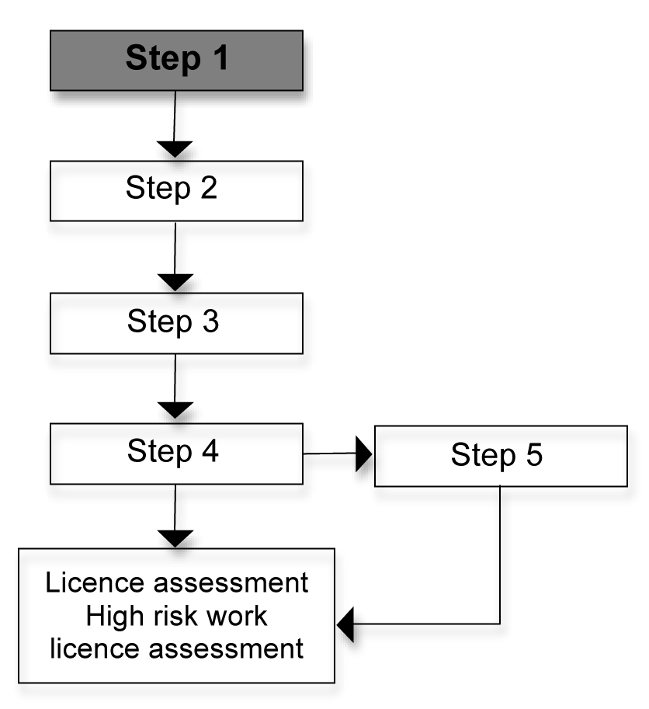
Step 1 – Application
Complete the application forms that are attached.

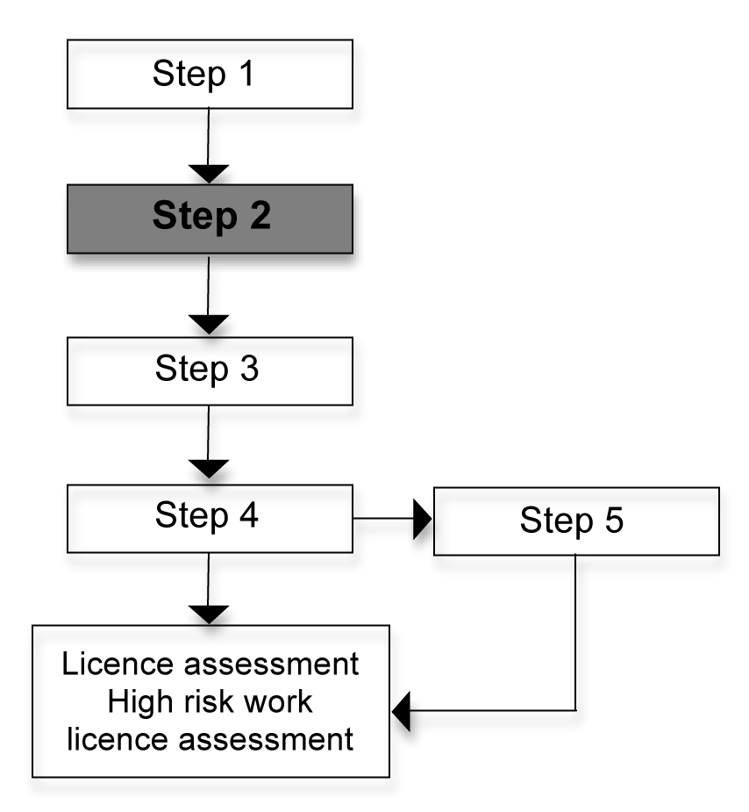

Step 2 – Provide information about your skills and experience
Complete the employment history form and provide as much information about your relevant industry experience as you can. This is your first opportunity to provide proof of your variety of experience in the industry. Provide evidence of your work history, which could include items from the following lists.

Section F – Assessor Evidence Summary, contains a list of the sorts of things that your assessor might be looking for. Try to source as many as you can. You will also need to have evidence of recent experience in this area of work (in the last 18 months). Think about who can confirm your skill level. Think about current or recent supervisors who have seen you working in the past 18 months and who can confirm your skills. Your RPL Assessor will need to contact these people. You may also have community contacts or clients who can confirm your skills level.

Be prepared to talk about your job roles and your work history. Bring a resume or write down a few points about where you have worked and what you did there, either paid or unpaid.
Bring your position description and any performance appraisals you have from any relevant industry you have worked in.
Think about people who could be good workplace contacts. Are you in a workplace that is helping you to get qualified? Would you feel comfortable to have your RPL Assessor contact your workplace or previous workplaces so your skills can be authenticated?
Collect any certificates from formal training or in-house training that you have done in the past.

You may or may not have documents as evidence depending on the industry you have worked in. This is not necessarily a problem as your RPL Assessor will work with you and give advice about what you need to do.
You will also need to supply contact details of one or two work referees who can confirm your skills in the industry.
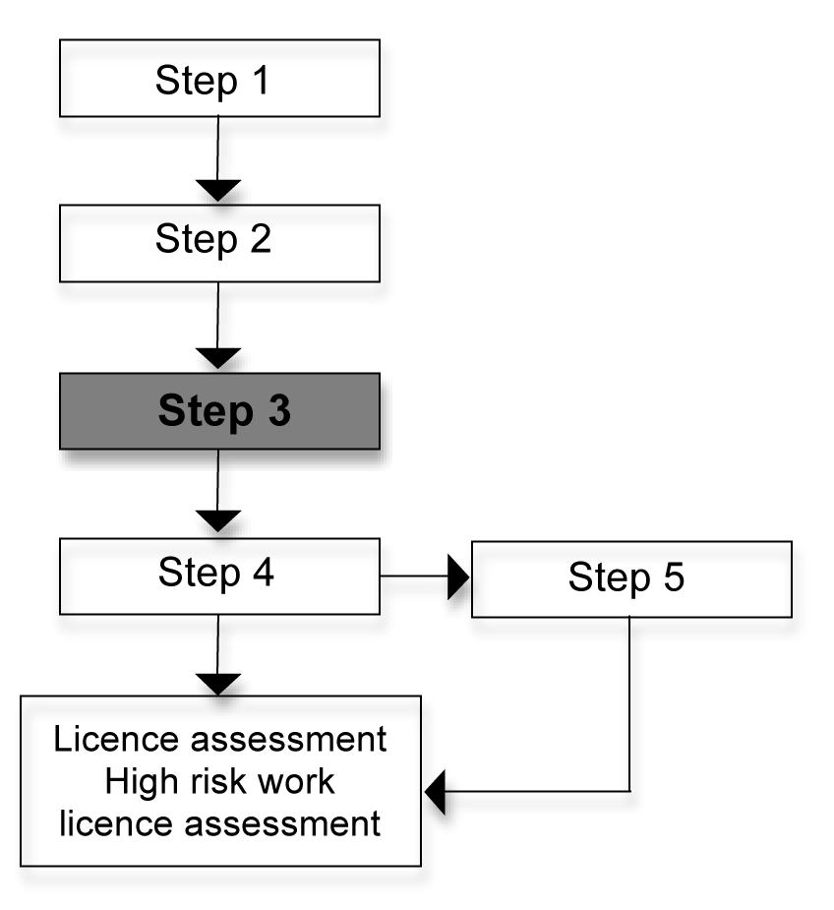
Step 3 – Conversation with the RPL Assessor
An RPL Assessor will look over the information you have provided (usually with you) and begin to match up your skills to the unit of competency. You will have the opportunity to discuss your previous experience with the RPL Assessor who will understand your industry experience. You will need to answer some related industry questions to identify your current skills.

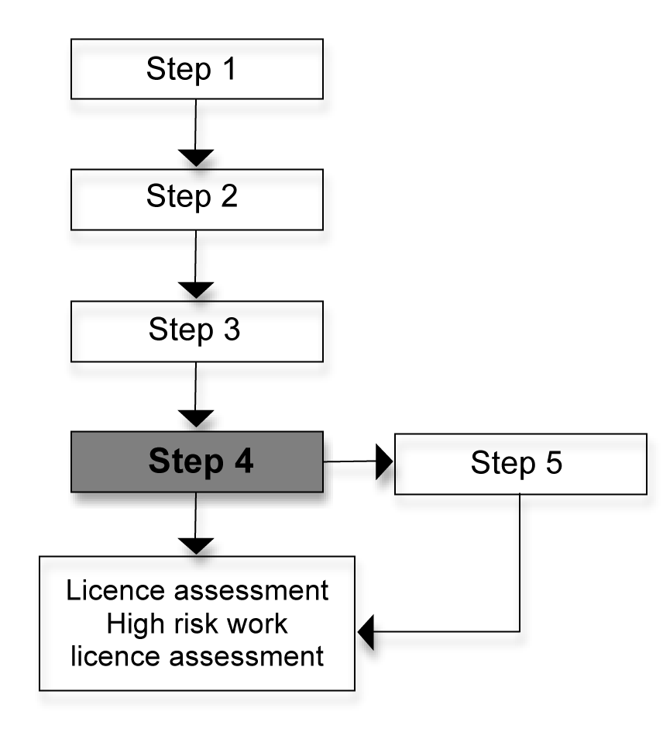
Step 4 – Practical demonstration of your skills
The RPL Assessor may conduct a practical skills demonstration at your workplace if this is appropriate or somewhere else that is suitable.
This is an opportunity for you to demonstrate your level of competence. The practical demonstration contains the practical skills and application of knowledge necessary for the unit of competency.
Your RPL Assessor will let you know the tasks that they want you to demonstrate.

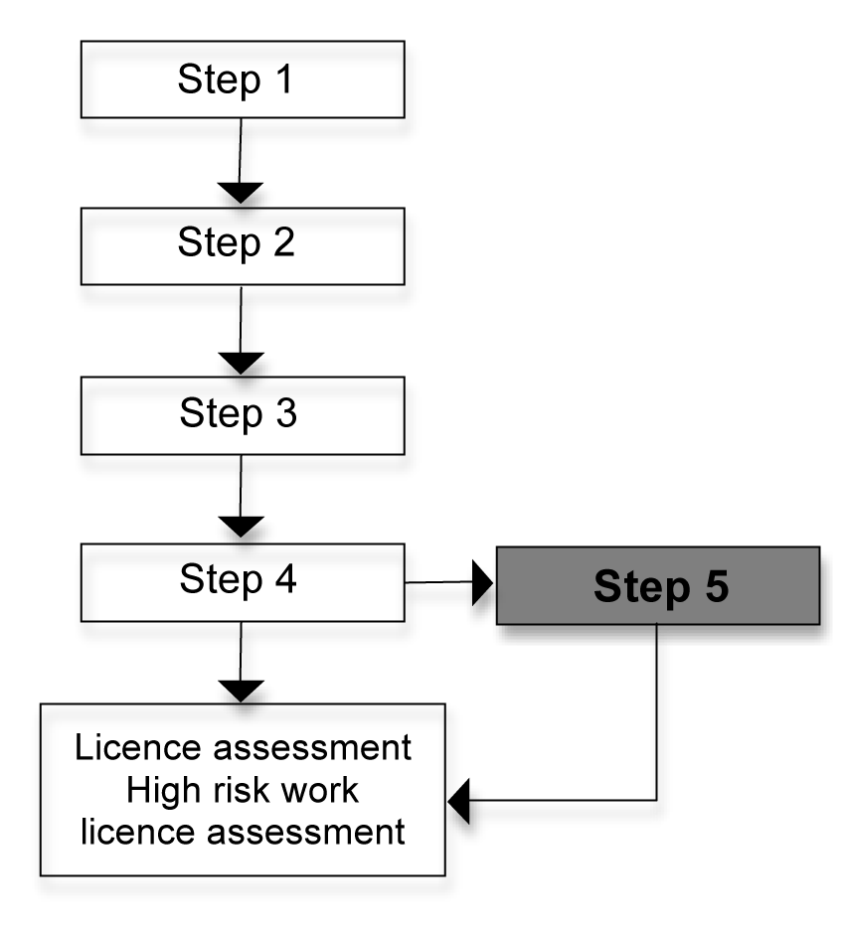
Step 5 – Further steps
After the conversation and practical demonstration, your RPL Assessor will give you information about the skills that have been recognised and whether you have demonstrated competency in the whole unit.
If you have skill gaps, you will need to enrol in the unit and your training requirements will be discussed with your trainer. You may be eligible to do the licence assessment if your RPL Assessor is satisfied that you are able to demonstrate all the necessary competencies in the unit.

